REPORT LAB 02: Problem Modeling and Encapsulation

Name: Lê Huy Dũng
Student ID: 20235919

Use case diagram
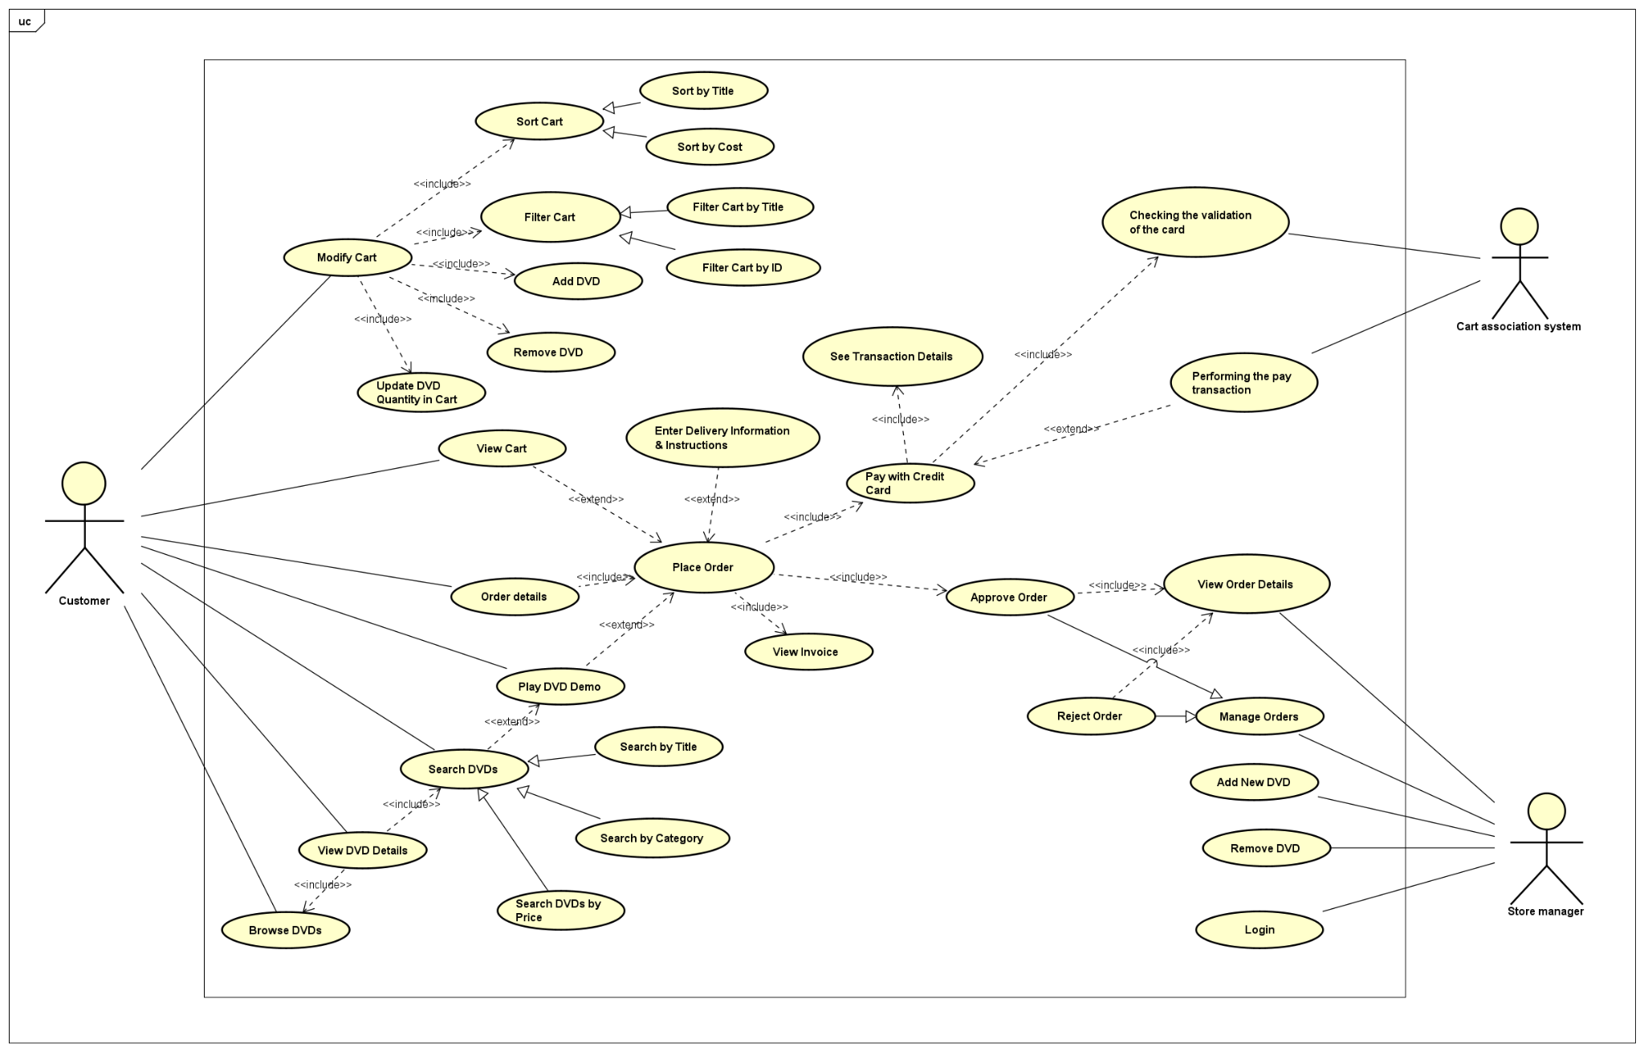
Class Diagram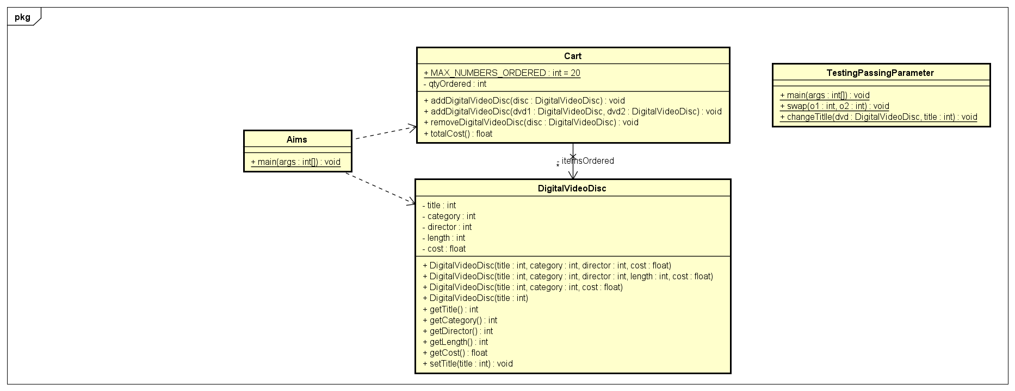

8. Create the DigitalVideoDisc class and its attributes
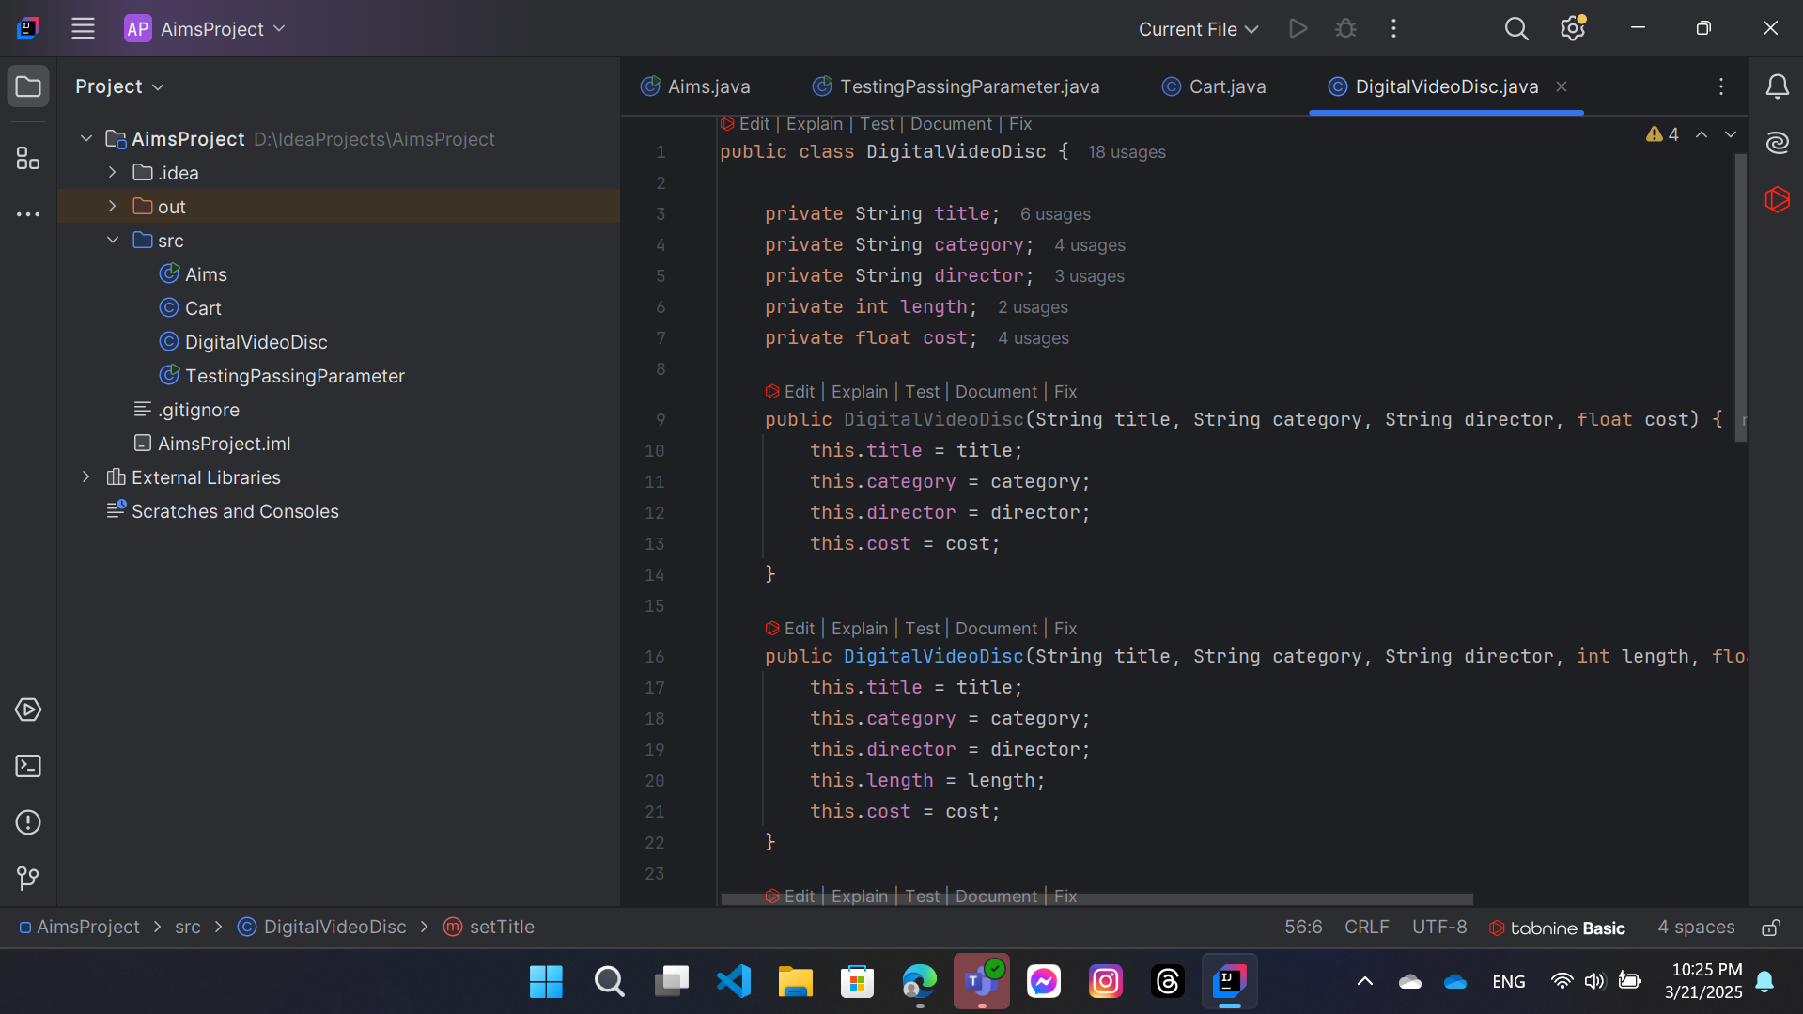

9. Create accessors and mutators for the class DigitalVideoDisc
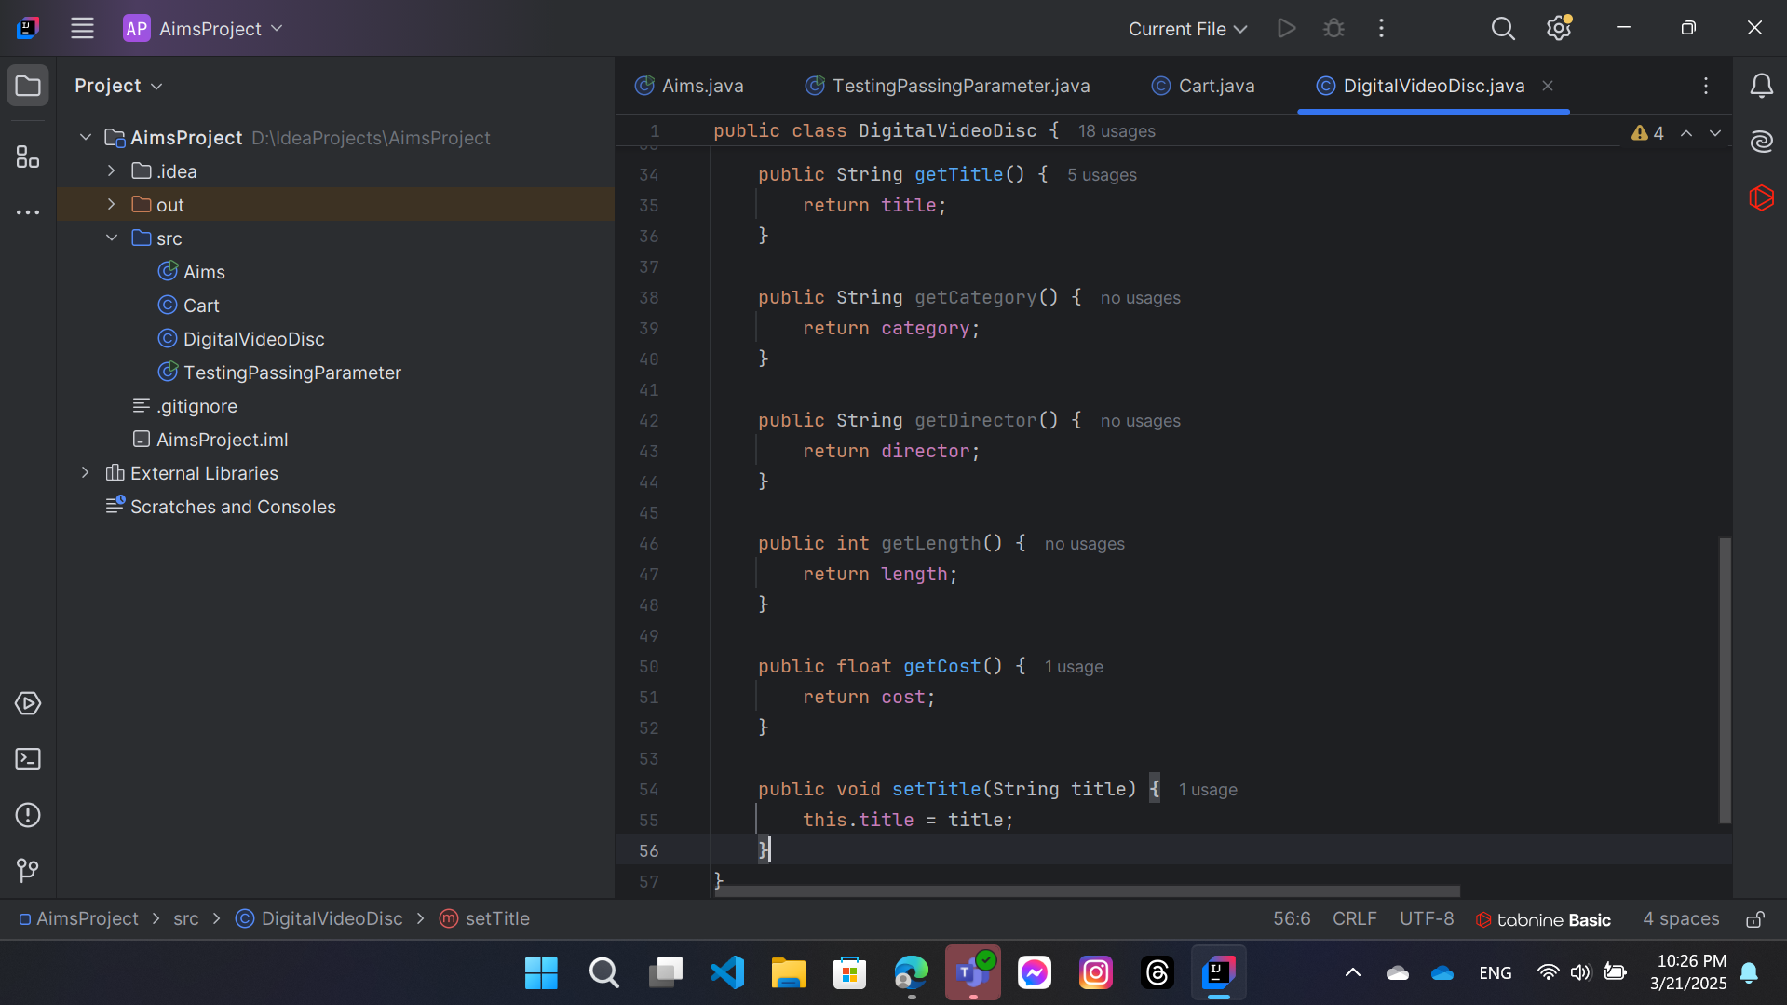

10. Create Constructor method
In this part, you will create yourself constructor method for DigitalVideoDisc for different purposes:

- Create a DVD object by title
- Create a DVD object by category, title and cost
- Create a DVD object by director, category, title and cost
- Create a DVD object by all attributes: title, category, director, length and cost

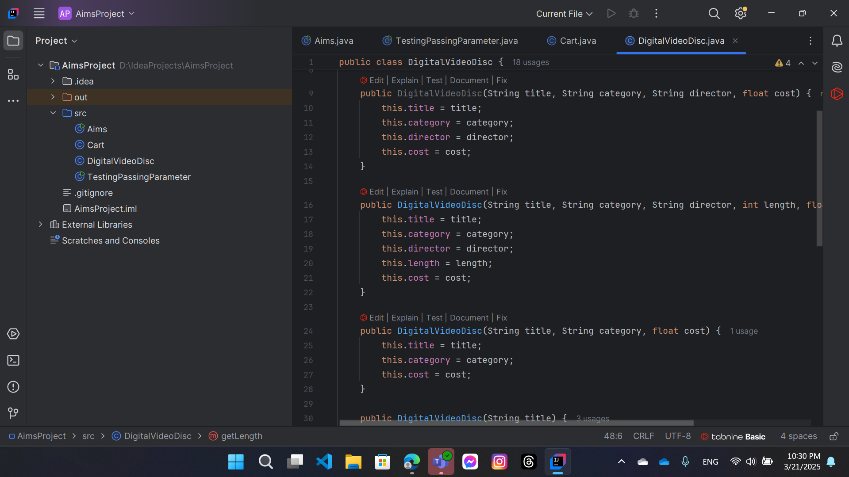

11. Create the Cart class to work with DigitalVideoDisc

Method addDigitalVideoDisc(DigitalVideoDisc disc)

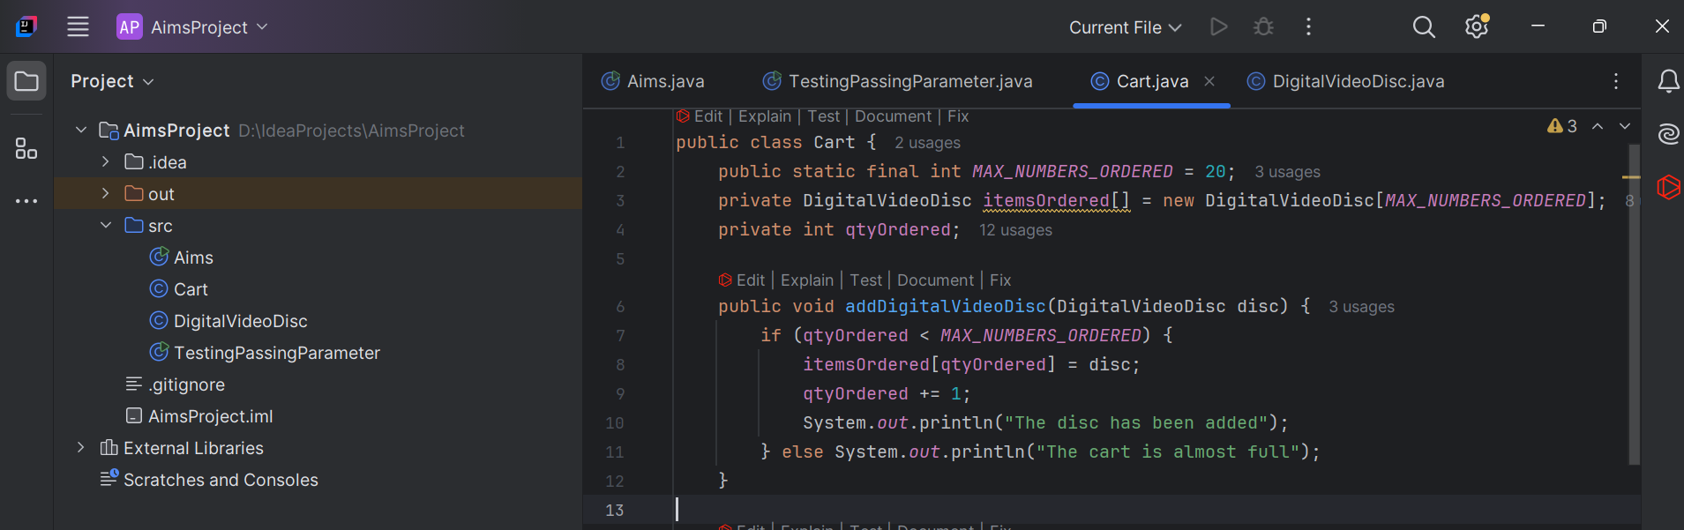

Method removeDigitalVideoDisc(DigitalVideoDisc disc)

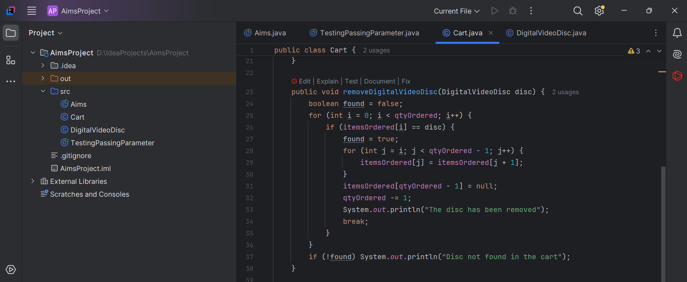

Method totalCost()

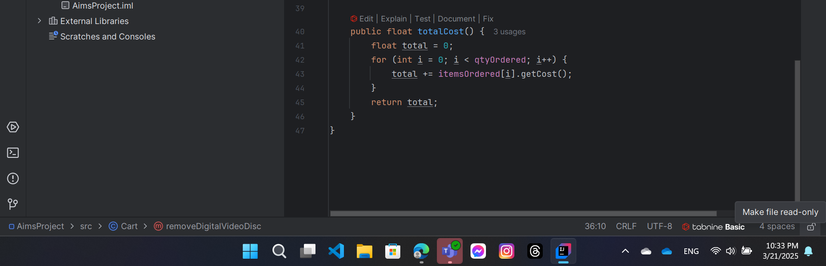

12.Create Carts of DigitalVideoDiscs & 13. Removing items from the cart

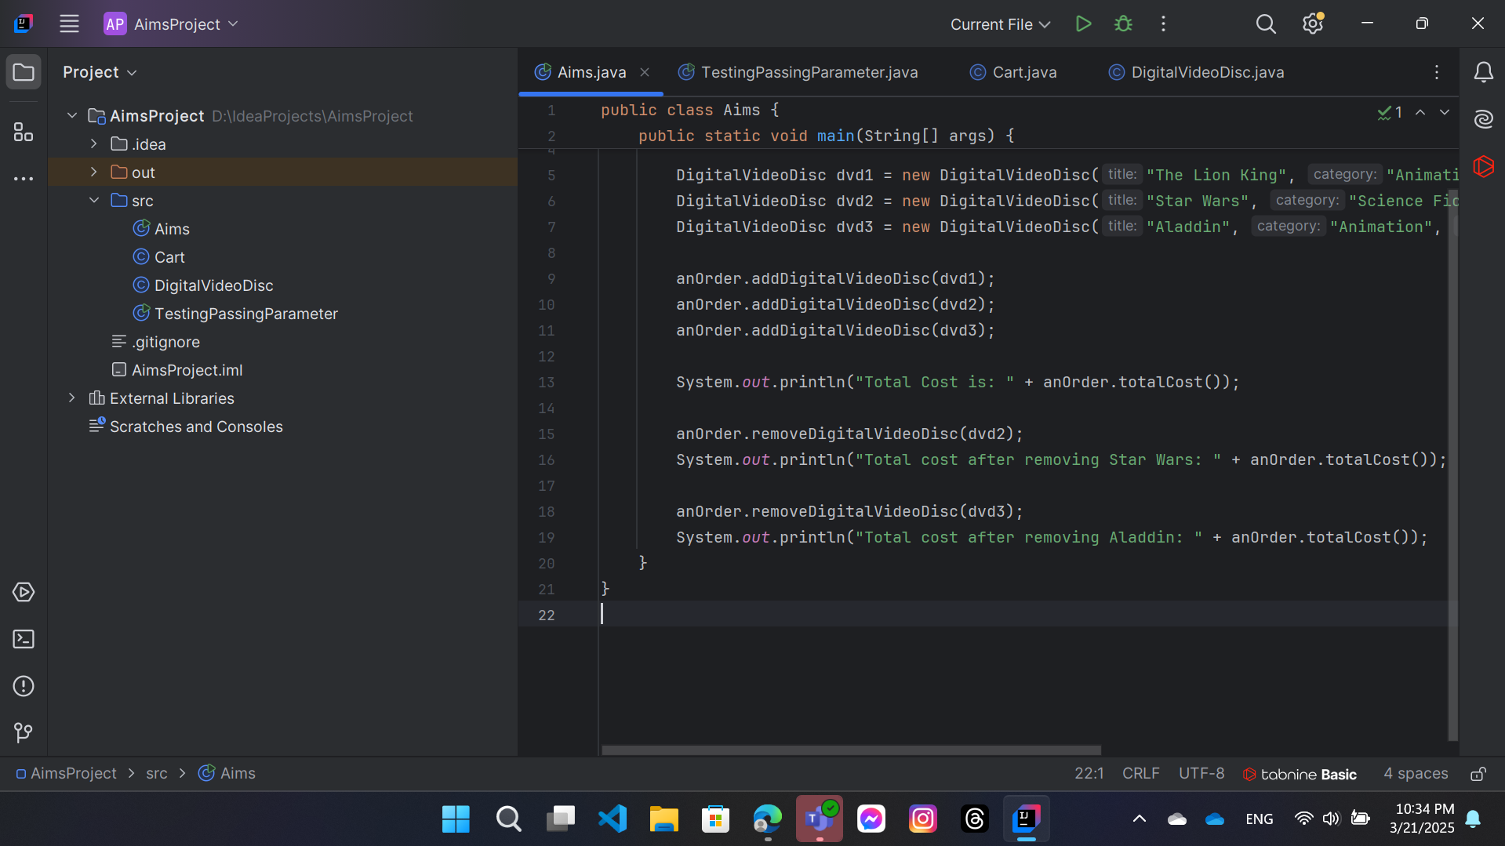

The output is:

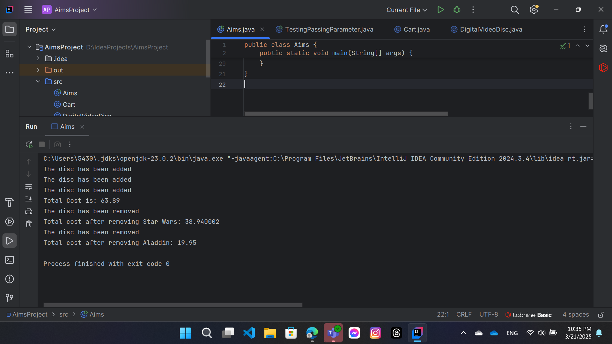

14. Working with method overloading
14.1 Overloading by differing types of parameter
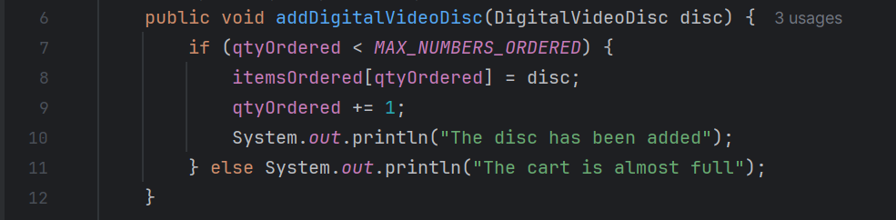

14.2 Overloading by differing the number of parameters

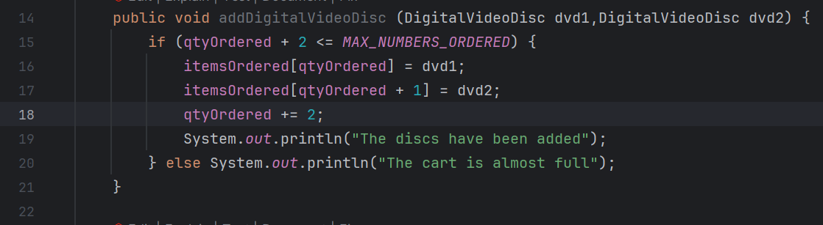

15. Passing parameter

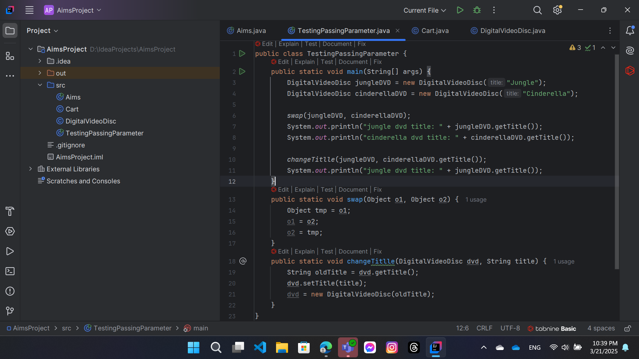

The result is:

